Lab 1: R Foundations for Risk and Insurance — Solutions
  - F71RA Machine Learning for Risk and Insurance 1
Table of contents

Before you start
Learning objectives. By the end of this lab you should be able to
- create and manipulate matrices in R (multiplication, inversion, transposition) and recognise when an operation is not defined;
- compute and interpret summary statistics for insurance data, with particular attention to skewness and heavy tails;
- simulate data from a known model, fit a linear regression with lm(), and check whether the fitted model recovers the truth.
Packages. Base R covers most of this lab. For Exercise 2.5 you will need the moments package:
install.packages("moments")
Reproducibility. Several exercises use random numbers. Run the chunk below once at the start of your session so that your “random” values match the model answers.
set.seed(71)

1. Matrix algebra
Almost every method in this course, from linear regression to neural networks, is a sequence of matrix operations. These exercises make sure you are comfortable with the basic building blocks in R.

Exercise 1.1: Creating a matrix
Create a $3×3$ matrix $M$ whose entries are random integers between 1 and 10 (use sample()). Print it, then print dim(M).
M <- matrix(sample(1:10, 9, replace = TRUE), nrow = 3)
M
[,1] [,2] [,3]
[1,] 1 8 7
[2,] 7 10 10
[3,] 2 5 3
dim(M)
[1] 3 3
Now create the same matrix with byrow = TRUE. In one sentence, explain what changed and why.
M_byrow <- matrix(as.vector(M), nrow = 3, byrow = TRUE)
M_byrow
[,1] [,2] [,3]
[1,] 1 7 2
[2,] 8 10 5
[3,] 7 10 3
Answer. The same nine numbers now appear row by row instead of column by column, so M_byrow is the transpose of M. By default R fills a matrix down the columns (column-major order); byrow = TRUE switches to filling across the rows.

Exercise 1.2: Matrix multiplication
Generate a random $4×3$ matrix $A$ and a random $3×2$ matrix $B$, and compute the product $C=AB$ using %*%.
A <- matrix(sample(1:10, 12, replace = TRUE), nrow = 4, ncol = 3)
B <- matrix(sample(1:10, 6, replace = TRUE), nrow = 3, ncol = 2)
C <- A %*% B
C
[,1] [,2]
[1,] 64 90
[2,] 38 72
[3,] 88 165
[4,] 102 129
Before you run any code: what are the dimensions of $C$? Check your answer with dim(C). Then try B %*% A and explain the error message. Finally, compare A %*% B with A * B (or explain why the second one fails).
dim(C)
[1] 4 2
B %*% A
Error in B %*% A: non-conformable arguments
A * B
Error in A * B: non-conformable arrays
Answer. $C$ is $4×2$: the number of rows of $A$ by the number of columns of $B$. B %*% A fails with “non-conformable arguments” because $B$ has 2 columns and $A$ has 4 rows, and matrix multiplication needs the inner dimensions to agree. A * B is elementwise multiplication, which needs the two matrices to have the same shape, so it also fails (“non-conformable arrays”). The two operators are completely different: %*% is the linear-algebra product, * multiplies entry by entry.

Exercise 1.3: Matrix inversion
Not every square matrix has an inverse. Create the following two matrices and compute det() for each:
$$X_{1}=\left(\begin{matrix}2 & 1 \\ 1 & 3\end{matrix}\right), X_{2}=\left(\begin{matrix}2 & 4 \\ 1 & 2\end{matrix}\right).$$
X1 <- matrix(c(2, 1, 1, 3), nrow = 2, byrow = TRUE)
X2 <- matrix(c(2, 4, 1, 2), nrow = 2, byrow = TRUE)
det(X1)
[1] 5
det(X2)
[1] 0
Use solve() to invert $X_{1}$, and verify that $X_{1}X_{1}^{−1}$ is the identity matrix. Then try to invert $X_{2}$. What happens, and how could you have predicted it from the determinant?
X1_inv <- solve(X1)
X1_inv
[,1] [,2]
[1,] 0.6 -0.2
[2,] -0.2 0.4
X1 %*% X1_inv
[,1] [,2]
[1,] 1.000000e+00 0
[2,] -1.110223e-16 1
solve(X2)
Error in solve.default(X2): Lapack routine dgesv: system is exactly singular: U[2,2] = 0
Answer. $det(X_{1})=5≠0$, so $X_{1}$ is invertible and $X_{1}X_{1}^{−1}$ gives the $2×2$ identity (up to floating-point rounding). $det(X_{2})=2⋅2−4⋅1=0$: the second row is exactly half the first, so the matrix is singular and solve() reports “Lapack routine dgesv: system is exactly singular”. A zero determinant always means no inverse exists.

Exercise 1.4: Transposition
Generate a random $4×2$ matrix $D$ and compute its transpose with t(). Then compute $D^{⊤}D$ and $DD^{⊤}$. What are their dimensions, and which one is more likely to be invertible? (You will meet $D^{⊤}D$ again in Section 3.)
D <- matrix(sample(1:10, 8, replace = TRUE), nrow = 4, ncol = 2)
D
[,1] [,2]
[1,] 5 6
[2,] 9 4
[3,] 8 1
[4,] 2 10
t(D)
[,1] [,2] [,3] [,4]
[1,] 5 9 8 2
[2,] 6 4 1 10
DtD <- t(D) %*% D
DDt <- D %*% t(D)
dim(DtD)
[1] 2 2
dim(DDt)
[1] 4 4
det(DtD)
[1] 17786
det(DDt)
[1] -2.11137e-25
Answer. $D^{⊤}D$ is $2×2$ and $DD^{⊤}$ is $4×4$. Both are symmetric. $D^{⊤}D$ is invertible whenever the two columns of $D$ are linearly independent, which is almost certain for random entries. $DD^{⊤}$ can never be invertible here: its rank is at most $rank(D)=2$, but it is $4×4$, so its determinant is zero (R returns a number of order ${10}^{−12}$ or exactly 0, depending on rounding). This is why the regression formula in Section 3 uses $(X^{⊤}X)^{−1}$, the small square matrix, and not the large one.

2. Descriptive statistics for claims data
In this section we work with a small simulated motor insurance portfolio. Claim sizes in practice are strongly right-skewed: most claims are small, and a few are very large. We simulate this with a lognormal distribution.

Exercise 2.1: Building the dataset
Run the chunk below to create a data frame claims with 500 policies. Each row records the driver’s age, the vehicle’s age, the sum insured, and the size of one claim.
n <- 500
claims <- data.frame(
driver_age = sample(18:80, n, replace = TRUE),
vehicle_age = sample(0:15, n, replace = TRUE),
sum_insured = round(runif(n, 5000, 40000), -2)
)
claims$claim_size <- exp(7 + 0.00003 * claims$sum_insured
- 0.01 * claims$driver_age + rnorm(n, 0, 0.8))
head(claims)
driver_age vehicle_age sum_insured claim_size
1 56 3 39800 3588.0591
2 39 6 8800 3019.7278
3 51 14 23100 2851.1860
4 57 15 14400 1126.3087
5 65 9 13200 1335.0275
6 66 6 15900 170.3911
Use str() and summary() to inspect the data. Which variable has the largest gap between its mean and its median? What does that tell you about its distribution?
str(claims)
'data.frame': 500 obs. of 4 variables:
$ driver_age : int 56 39 51 57 65 66 34 80 61 32 ...
$ vehicle_age: int 3 6 14 15 9 6 3 1 11 5 ...
$ sum_insured: num 39800 8800 23100 14400 13200 15900 35200 24800 34500 34900 ...
$ claim_size : num 3588 3020 2851 1126 1335 ...
summary(claims)
driver_age vehicle_age sum_insured claim_size
Min. :18.00 Min. : 0.000 Min. : 5000 Min. : 70.68
1st Qu.:32.00 1st Qu.: 4.000 1st Qu.:12875 1st Qu.: 745.60
Median :51.00 Median : 8.000 Median :22800 Median : 1316.16
Mean :49.26 Mean : 7.466 Mean :22221 Mean : 1901.23
3rd Qu.:65.00 3rd Qu.:11.000 3rd Qu.:30725 3rd Qu.: 2259.09
Max. :80.00 Max. :15.000 Max. :39900 Max. :21114.41
Answer. claim_size has by far the largest gap, with the mean well above the median. For the other three variables the two are close, as expected for uniform-ish data. A mean pulled above the median is the signature of right skew: a minority of very large claims drag the average up while leaving the typical (median) claim unchanged.

Exercise 2.2: Variance and standard deviation
Compute the variance and standard deviation of claim_size using var() and sd().
var(claims$claim_size)
[1] 4008105
sd(claims$claim_size)
[1] 2002.025
R’s var() divides by $n−1$, not $n$. Compute the population variance by hand (i.e. $\frac{1}{n}∑(x_{i}−\overset{‾}{x})^{2}$) and confirm the two differ by a factor of $(n−1)/n$. Why does R use $n−1$ by default?
x <- claims$claim_size
pop_var <- mean((x - mean(x))^2)
pop_var
[1] 4000089
pop_var / var(x)
[1] 0.998
(n - 1) / n
[1] 0.998
Answer. The ratio is exactly $(n−1)/n=499/500=0.998$. R divides by $n−1$ because the sample mean $\overset{‾}{x}$ is itself estimated from the data, which uses up one degree of freedom; dividing by $n−1$ (Bessel’s correction) makes the sample variance an unbiased estimator of the population variance. With $n=500$ the difference is negligible, but for small samples it matters.

Exercise 2.3: Histograms
Draw a histogram of claim_size with roughly 30 bins. Then draw a histogram of log(claim_size). Describe the shape of each in one sentence.
hist(claims$claim_size, breaks = 30,
main = "Claim size", xlab = "Claim size")
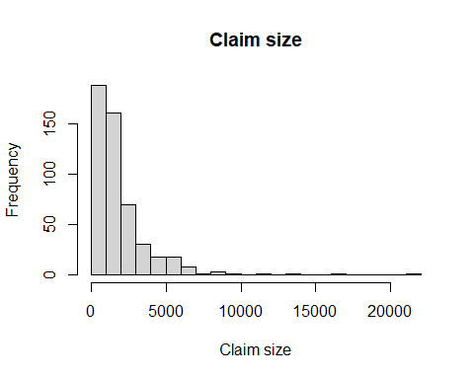
hist(log(claims$claim_size), breaks = 30,
main = "Log claim size", xlab = "log(claim size)")
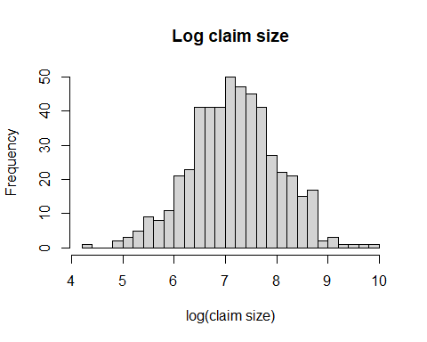
Answer. The raw claim sizes are heavily right-skewed: a tall spike of small claims and a long thin tail stretching to the right. On the log scale the distribution is roughly symmetric and bell-shaped, because we generated the data as $exp(\text{normal})$, i.e. lognormal.
Why do actuaries so often model claim sizes on the log scale? What would go wrong if you fitted a normal distribution directly to claim_size?
Answer. Claim sizes are positive and right-skewed, and a log transform turns multiplicative effects (a 10% larger sum insured leads to roughly x% larger claims) into additive ones, which linear models handle well. A normal distribution fitted directly to claim_size would be symmetric about the mean, so it would put substantial probability on negative claims and would badly under-estimate the probability of very large claims, which is exactly the tail an insurer needs to reserve for.

Exercise 2.4: Correlation
Compute the correlation matrix of driver_age, vehicle_age, sum_insured and claim_size using cor().
round(cor(claims), 3)
driver_age vehicle_age sum_insured claim_size
driver_age 1.000 0.013 0.038 -0.137
vehicle_age 0.013 1.000 -0.060 -0.047
sum_insured 0.038 -0.060 1.000 0.333
claim_size -0.137 -0.047 0.333 1.000
Which variables are most strongly related to claim_size? Do the signs match how the data were generated in Exercise 2.1? Produce a scatter plot of claim_size against the strongest predictor.
plot(claims$sum_insured, claims$claim_size,
xlab = "Sum insured", ylab = "Claim size",
main = "Claim size against sum insured")
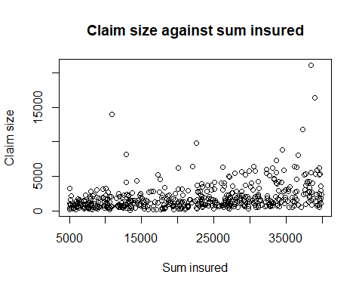
Answer. sum_insured has the strongest correlation with claim_size (positive, around 0.3–0.4), followed by driver_age (negative, around $−0.15$). vehicle_age is essentially uncorrelated with everything. The signs match the generating equation: claim size increases with sum insured and decreases with driver age, and vehicle age was never used. Note that the correlations are only moderate because the noise term ($σ=0.8$ on the log scale) is large, and because Pearson correlation measures linear association whereas the true relationship is exponential; correlations on log(claim_size) are noticeably stronger.

Exercise 2.5: Skewness and kurtosis
Skewness measures asymmetry; a right-skewed distribution has a long right tail and positive skewness. Kurtosis measures how heavy the tails are relative to a normal distribution, which has kurtosis 3.
Using the moments package, compute the skewness and kurtosis of claim_size and of log(claim_size).
library(moments)
skewness(claims$claim_size)
[1] 3.947301
kurtosis(claims$claim_size)
[1] 28.61202
skewness(log(claims$claim_size))
[1] -0.01393663
kurtosis(log(claims$claim_size))
[1] 3.112735
Now simulate 500 values from $N(0,1)$ and compute the same two quantities. Comment on the differences. Why do heavy tails matter for an insurer more than for, say, a retailer analysing customer heights?
z <- rnorm(500)
skewness(z)
[1] 0.2588585
kurtosis(z)
[1] 3.119975
Answer. The raw claim sizes have large positive skewness (typically 3–5) and very high kurtosis (well above 3, often 20 or more), while both log(claim_size) and the $N(0,1)$ sample have skewness near 0 and kurtosis near 3. Note that the sample kurtosis of claim sizes is unstable: it is driven by the handful of largest claims and will jump around if you change the seed.
Heavy tails matter for an insurer because the tail is the risk. A retailer’s customers’ heights vary within a narrow band and an extreme observation is of no financial consequence. For an insurer, a single claim in the far right tail can exceed the total premium collected from thousands of policies, so pricing, reserving and reinsurance all hinge on getting the tail right, and a model that assumes normal (light) tails will systematically understate it.

3. Linear regression
We now fit our first predictive model. The key idea in this section is to simulate data from a model whose parameters you know, fit the model, and check whether the fit recovers the truth. This is a habit you should keep for every method in the course.

Exercise 3.1: Simple linear regression
Simulate 200 observations from the model
$$Y=2+3X+ε, X∼N(0,1), ε∼N(0,1).$$
Store them in a data frame sim.
m <- 200
sim <- data.frame(X = rnorm(m))
sim$Y <- 2 + 3 * sim$X + rnorm(m)
head(sim)
X Y
1 -1.28264024 -1.260926
2 -0.08216871 2.306658
3 -0.17699136 1.588068
4 0.18616815 2.856567
5 0.71845057 5.108306
6 -0.22385676 3.033934
Fit the model lm(Y ~ X, data = sim), print coef(), and plot the data with the fitted line added using abline(). How close are the estimated intercept and slope to 2 and 3?
fit1 <- lm(Y ~ X, data = sim)
coef(fit1)
(Intercept) X
2.006787 3.122190
plot(sim$X, sim$Y, xlab = "X", ylab = "Y", main = "Simple linear regression")
abline(fit1, col = "red", lwd = 2)
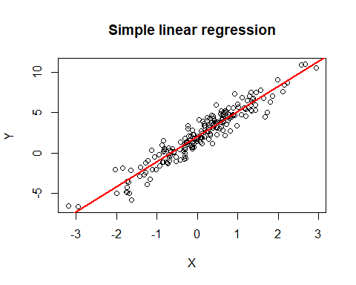
Answer. The intercept comes out almost exactly 2 and the slope around 3.1, so both are close to the truth but not identical. With 200 observations and noise standard deviation 1, each standard error is roughly $0.07$, so an estimate that is within about two standard errors of the true value (as here) is exactly what we should expect. Changing the seed moves the estimates around within that band.

Exercise 3.2: Multiple linear regression
Add a second predictor $Z∼N(0,1)$ and regenerate $Y$ from
$$Y=2+3X−1.5Z+ε.$$
Fit lm(Y ~ X + Z, data = sim) and look at summary().
sim$Z <- rnorm(m)
sim$Y <- 2 + 3 * sim$X - 1.5 * sim$Z + rnorm(m)
fit2 <- lm(Y ~ X + Z, data = sim)
summary(fit2)
Call:
lm(formula = Y ~ X + Z, data = sim)
Residuals:
Min 1Q Median 3Q Max
-2.46064 -0.65586 -0.01911 0.51359 2.79206
Coefficients:
Estimate Std. Error t value Pr(>|t|)
(Intercept) 2.03648 0.07083 28.75 <2e-16 ***
X 2.92099 0.07087 41.22 <2e-16 ***
Z -1.42434 0.07663 -18.59 <2e-16 ***
---
Signif. codes: 0 '***' 0.001 '**' 0.01 '*' 0.05 '.' 0.1 ' ' 1
Residual standard error: 0.9944 on 197 degrees of freedom
Multiple R-squared: 0.9154, Adjusted R-squared: 0.9146
F-statistic: 1066 on 2 and 197 DF, p-value: < 2.2e-16
Answer the following in words:
- What does the coefficient on $Z$ mean in plain language?
- Is each coefficient statistically significant? Which column of the summary tells you this?
- What does the $R^{2}$ value tell you, and why is it not 1 even though you know the true model?
Answers.
- Holding $X$ fixed, a one-unit increase in $Z$ is associated with a change in $Y$ of about $−1.5$ units. It is a partial effect: it describes what happens to $Y$ when $Z$ changes and $X$ does not.
- Yes, all three: the Pr(>|t|) column gives the p-value for the test that each coefficient is zero, and all are far below 0.05 (the intercept and $X$, $Z$ are all < 2e-16 or close to it). The t value column is the estimate divided by its standard error, and the Std. Error column tells you how precisely each coefficient has been estimated.
- $R^{2}$ is the proportion of the variance in $Y$ explained by the model, here around 0.9. It is below 1 because $Y$ contains the irreducible noise $ε$, which no model can predict. The true model itself only explains $Var(3X−1.5Z)/Var(Y)=11.25/12.25≈0.92$ of the variance, so an $R^{2}$ near 0.92 is the best any fitted model can honestly achieve.

Exercise 3.3: Regression on real-ish data
Return to the claims data from Section 2. Fit a linear regression of log(claim_size) on driver_age, vehicle_age and sum_insured.
fit_claims <- lm(log(claim_size) ~ driver_age + vehicle_age + sum_insured,
data = claims)
summary(fit_claims)
Call:
lm(formula = log(claim_size) ~ driver_age + vehicle_age + sum_insured,
data = claims)
Residuals:
Min 1Q Median 3Q Max
-2.44131 -0.52077 0.01367 0.56079 2.63697
Coefficients:
Estimate Std. Error t value Pr(>|t|)
(Intercept) 6.833e+00 1.350e-01 50.595 < 2e-16 ***
driver_age -8.444e-03 1.864e-03 -4.530 7.38e-06 ***
vehicle_age 3.973e-03 7.661e-03 0.519 0.604
sum_insured 3.314e-05 3.340e-06 9.921 < 2e-16 ***
---
Signif. codes: 0 '***' 0.001 '**' 0.01 '*' 0.05 '.' 0.1 ' ' 1
Residual standard error: 0.7744 on 496 degrees of freedom
Multiple R-squared: 0.1891, Adjusted R-squared: 0.1842
F-statistic: 38.55 on 3 and 496 DF, p-value: < 2.2e-16
Compare the fitted coefficients with the values used to generate the data in Exercise 2.1. Which predictor is doing nothing, and does the model agree?
Answer. The generating equation was $log(\text{claim})=7−0.01 \text{driver_age}+0.00003 \text{sum_insured}+ε$ with no vehicle_age term. The fitted intercept, driver_age and sum_insured coefficients are all close to $7$, $−0.01$ and $3×{10}^{−5}$ respectively, and both predictors are highly significant. vehicle_age is the one doing nothing: its coefficient is close to zero and its p-value is large, so the model correctly reports no evidence of an effect. Note how much cleaner this is on the log scale than the correlations in Exercise 2.4 suggested: the regression is fitting the right functional form, so the true signal comes through.

Stretch exercise: regression by hand
The lm() function solves the normal equations. For a design matrix $X$ (with a column of ones for the intercept) and response vector $y$, the least-squares estimate is
$$\hat{β}=(X^{⊤}X)^{−1}X^{⊤}y.$$
Using only the matrix tools from Section 1 (cbind(), t(), %*%, solve()), compute $\hat{β}$ for the model in Exercise 3.2 and confirm it matches coef() from lm().
Xmat <- cbind(1, sim$X, sim$Z)
y <- sim$Y
beta_hat <- solve(t(Xmat) %*% Xmat) %*% t(Xmat) %*% y
beta_hat
[,1]
[1,] 2.036479
[2,] 2.920991
[3,] -1.424338
coef(fit2)
(Intercept) X Z
2.036479 2.920991 -1.424338
Why did we need $X^{⊤}X$ to be invertible? What would happen if $Z$ were an exact linear function of $X$? Try it.
sim$Z2 <- 2 * sim$X + 1
Xmat2 <- cbind(1, sim$X, sim$Z2)
det(t(Xmat2) %*% Xmat2)
[1] 4.040419e-08
solve(t(Xmat2) %*% Xmat2)
Error in solve.default(t(Xmat2) %*% Xmat2): system is computationally singular: reciprocal condition number = 7.23098e-17
lm(Y ~ X + Z2, data = sim)
Call:
lm(formula = Y ~ X + Z2, data = sim)
Coefficients:
(Intercept) X Z2
2.061 2.991 NA
Answer. The estimates from the normal equations match coef(fit2) to machine precision, so lm() really is just doing this matrix calculation (with a numerically safer algorithm). The formula requires $X^{⊤}X$ to be invertible, which holds exactly when the columns of $X$ are linearly independent. If $Z$ is an exact linear function of $X$, one column of $X$ is a combination of the others, $X^{⊤}X$ is singular, and solve() fails: there are infinitely many $\hat{β}$ giving the same fitted values. This is perfect multicollinearity. lm() handles it gracefully by reporting NA for the redundant coefficient rather than crashing.

